Test Plan:

A test plan is a document describing the scope, approach, objectives, resources, and schedule of a software testing effort. It is the document that outlines what, when, how, who, and more of a testing project.

Value of Test Plan:

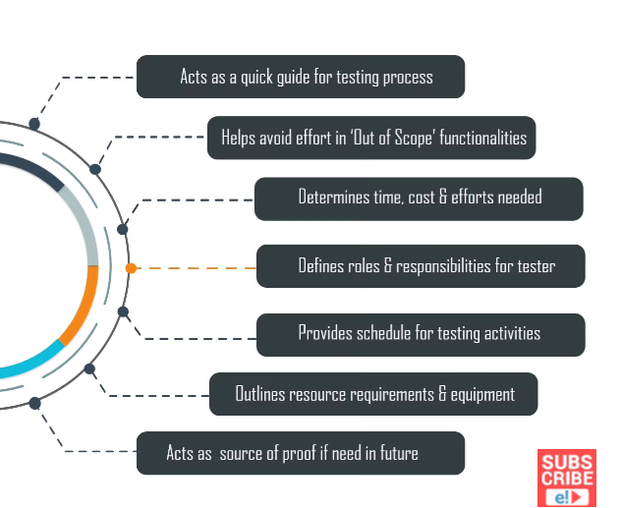

Standard for test plan documentation:

Test Plan Identifier – Uniquely identifies the test plan & may include version number.

Introduction – Sets objectives, scope, goals, resources & budget constraints.

Test Items – Lists the systems and subsystem which be tested.

Features to be tested – All the features & functionalities to be tested are listed here.

Features not to be tested – Lists the characteristics of product that need not be tested.

Approach – Has sources of test data, inputs, and outputs, testing priorities.

Item pass/fail – Describes a success criterion for evaluating the test results.

Suspension Criteria – Has criteria that may result in suspending testing activities.

Test Deliverables – includes test cases, sample data, test report, issues log.

Testing Tasks – Describes dependencies between tasks & resources needed.

Environmental Needs – Lists software, hardware, or other testing requirements.

Responsibilities – Lists roles and responsibility assigned to the testing team.

Staffing needs – Describes the additional training needs for the staff.

Schedule – Details on when the testing activities will take place are listed.

Risks – Lists overall risk of the project as it pertains to testing.

Approvals – Contains signature of approval from stakeholders.